Adaptive Needle Guide Assembly Procedure

# Linear Stages

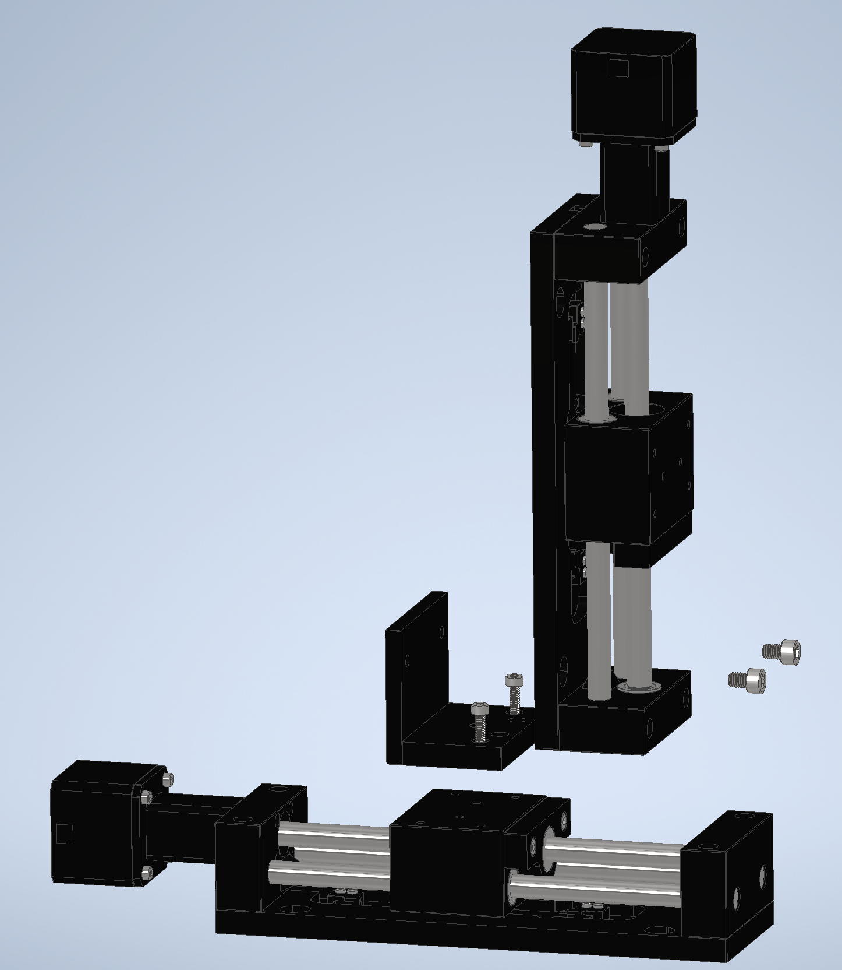

(2) M4-0.7x12 SHC

ET-Z Bracket

ET-100-11 Linear Stage

(2) M6-1x8 SHC

* Place (1) of the ET-100-11 Linear Stages flat and horizontal on a surface
* Place ET-Z bracket on top of ET-100-11 Linear Stage, secure with (2) M4-0.7x12 SHC screws
* Place the other ET-100-11 Linear Stage on ET-Z bracket, secure with (2) M6-1x8 SHC screws

# Base

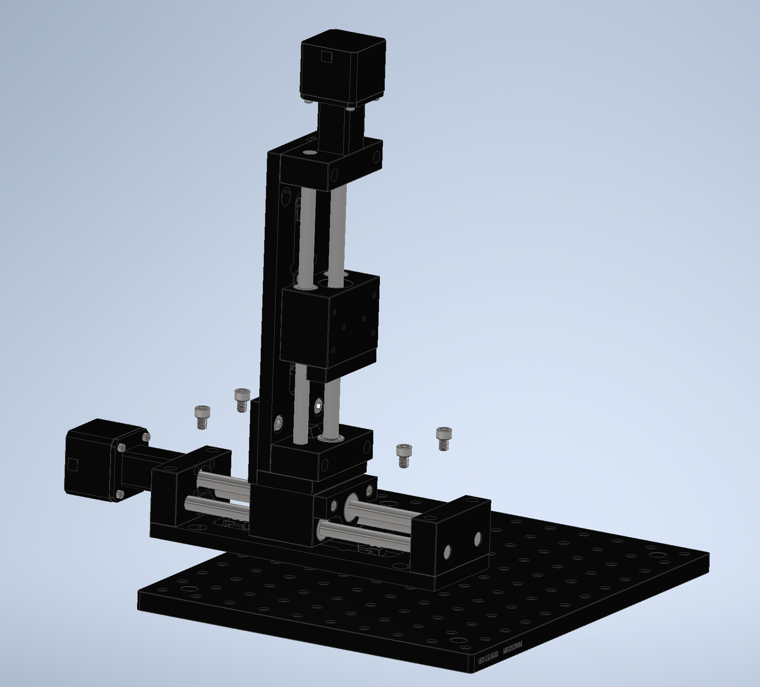

Thorlabs Breadboard 250mm x 300mm

(4) M6-1x8 SHC

Linear Stage Assembly

* Place 250mm x 300mm Thorlabs Breadboard on a surface such that 300mm is along the width and 250mm is along the depth
* We’ll define a hole naming convention where rows are labeled alphabetically from top (A) to bottom (J), and columns are labeled numerically from left (1) to right (12)
* Place Linear Stage Assembly on Thorlabs Breadboard, aligning slots in Linear Stage Assembly with holes B1, B3, H1, and H3 on the Breadboard, secure with (4) M6-1x8 SHC screws

# Supports

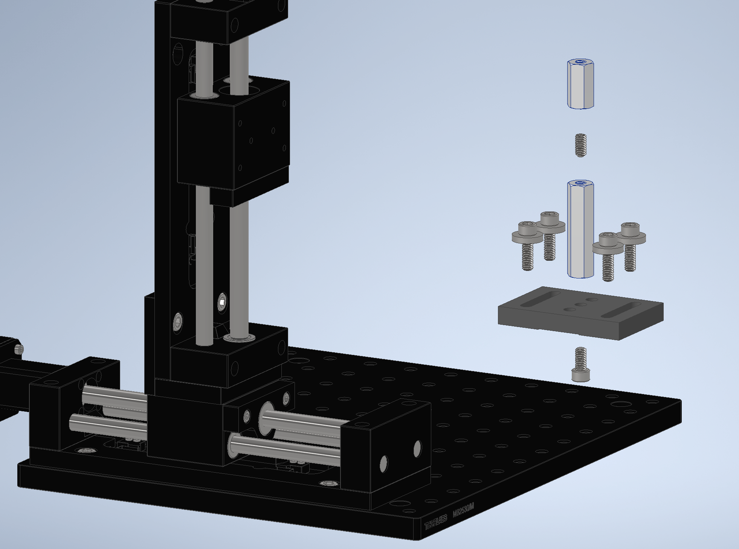

BA2/M Base

(4) M6-1x20 SHC

& M6 Washer

M6-1x12 SHC

Hex Standoff 52mm

M6 12mm Set Screw

Hex Standoff 25mm

* Place Hex Standoff 52mm on BA2/M Base, lining up Standoff with center hole in Base, secure with M6-1x12 SHC Screw from other side
* Thread M6 Set Screw a little less than halfway onto top of Hex Standoff 52mm
* Thread Hex Standoff 25mm onto M6 Set Screw, tighten onto Hex Standoff 52mm
* Place support assembly onto Thorlabs Breadboard, lining up slots in Base with holes in Breadboard
* Secure Base to Breadboard using (4) M6-1x20 SHC Screw and M6 Washer, into holes: H10, H11, J10, J11
* Repeat X3, securing Support structures to the following sets of holes: [H4, H5, J4, J5], [B4, B5, D4 D5], [B10, B11, D10, D11]

# Top Platform

Phantom Base Adapter

(2) M6-1x12 SHC

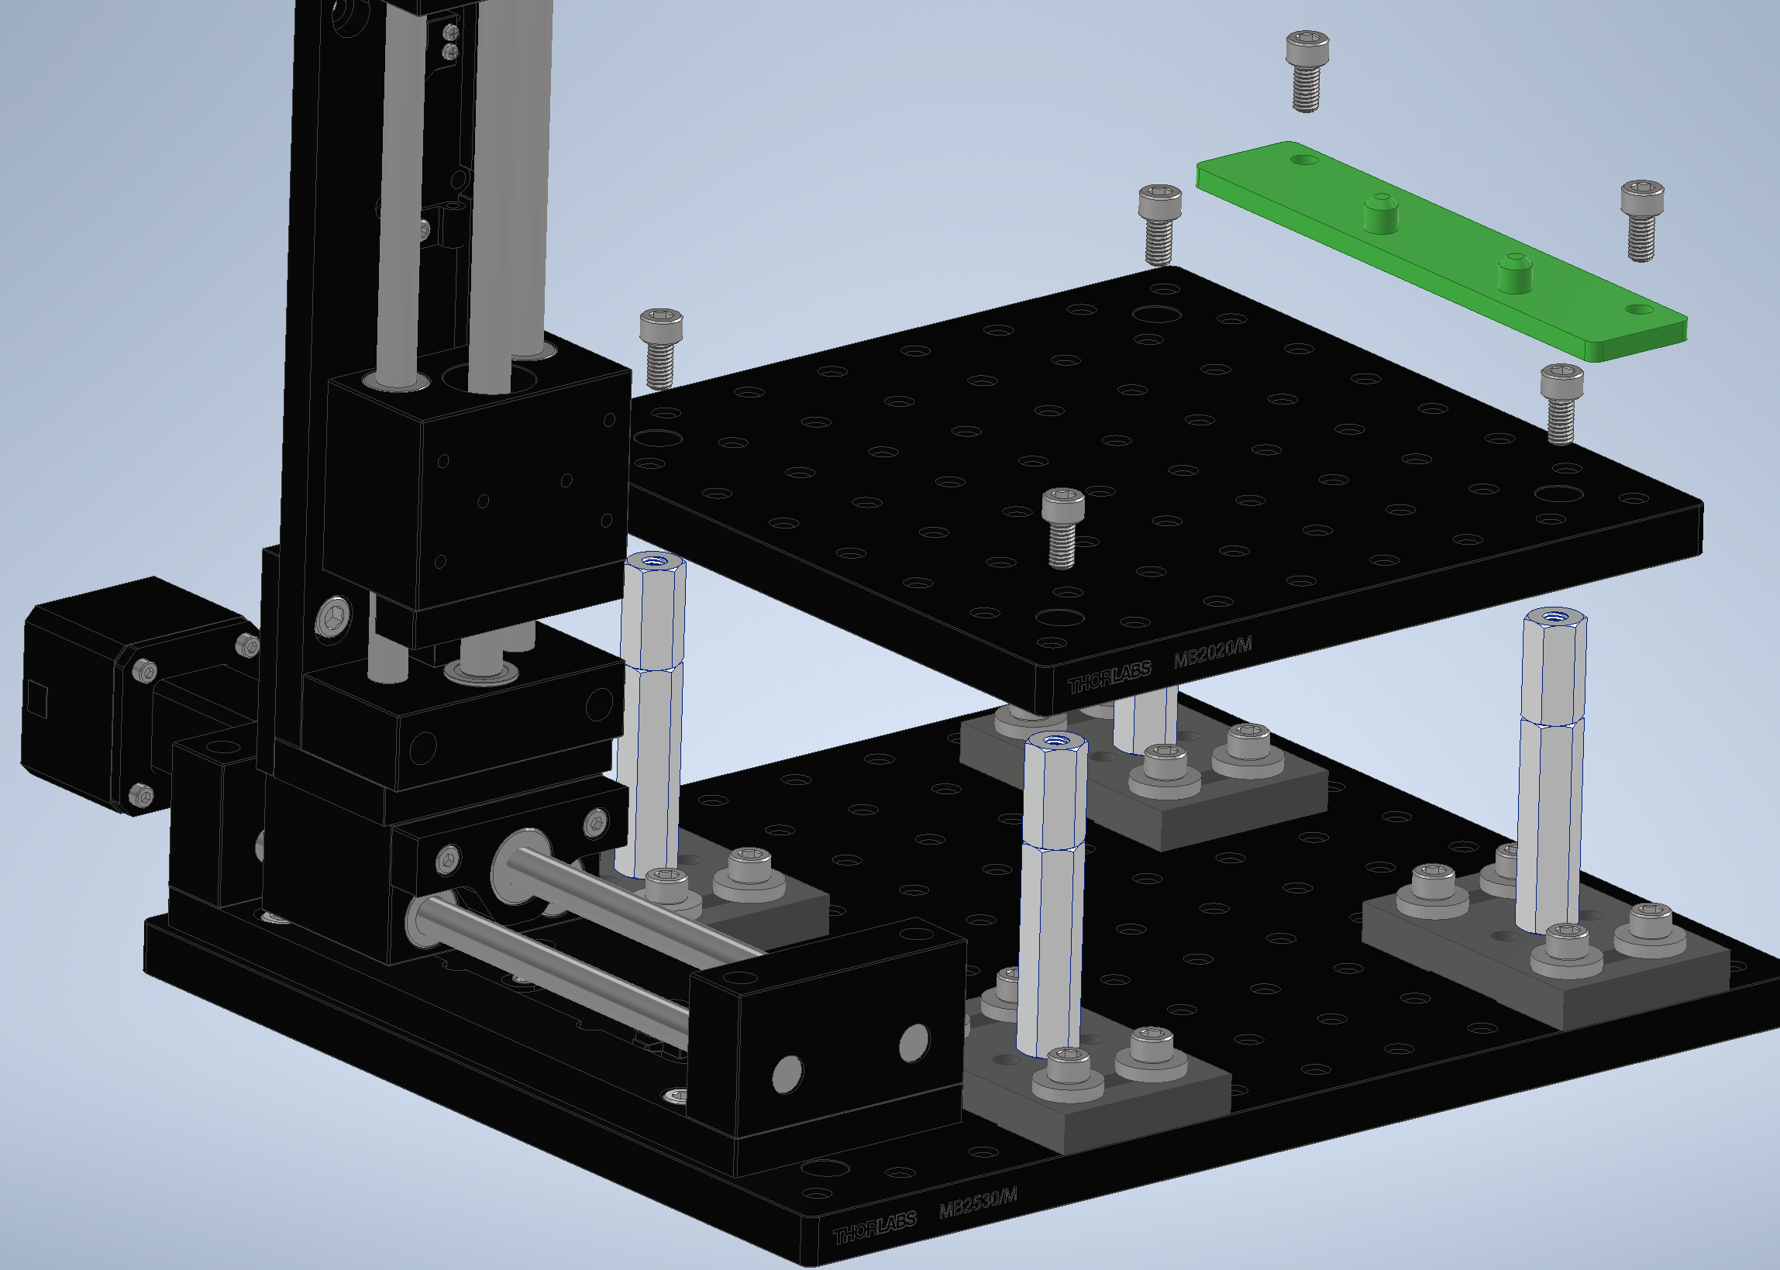

Thorlabs Breadboard 200mm x 200mm

(4) M6-1x12 SHC

* Place Thorlabs Breadboard 200mm x 200mm onto the support structures, lining up with the four counterbore holes in the corners of the breadboard, secure with (4) M6-1x12 SHC Screws
* Place Phantom Base Adapter onto Breadboard, lining up holes in Adapter with holes: C8 and H8 on the Breadboard, secure with (2) M6-1x12 SHC Screws

# Needle Guide Rail

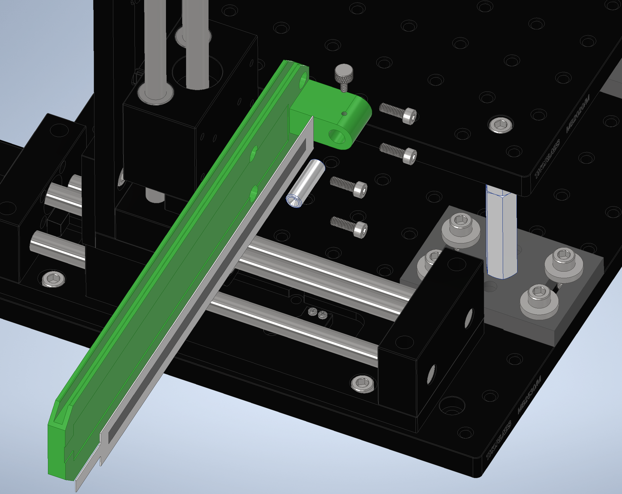

Rail

Needle Guide 18 Gauge

M3 Thumb Screw

(4) M4-0.7x12 SHC

Softpot Sensor

* Attach 3-Pin Connector (COM-14197) to SoftPot Linear Potentiometer
* Solder wires to 3-Pin Connector
* Attach Softpot Linear Potentiometer to Groove in Rail using adhesive backing
* Insert Needle Guide into Rail, with larger chamfer side in Needle Guide facing out, secure with M3 Thumb Screw
* Place Rail against Linear Stage, secure with (4) M4-0.7x12 Screws

# Needle Assembly

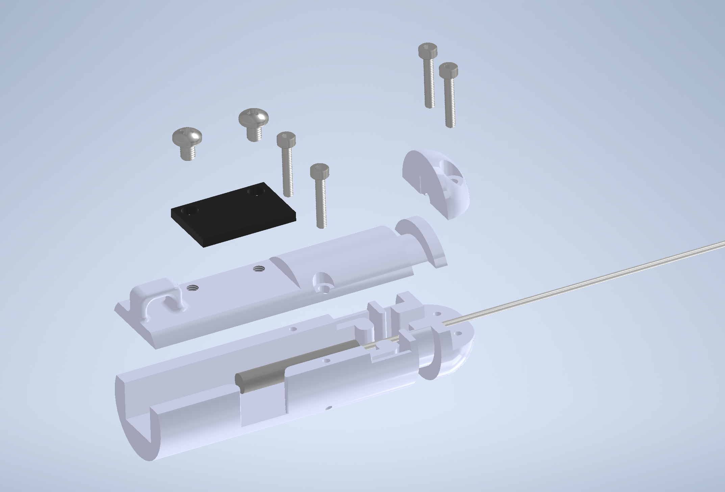

Needle Holder Top

Needle Holder Cap

(2) M2-0.4x12 SHC

IMU

Needle

Needle Holder Bottom

M3-0.5x4 Philips

(2) M2-0.4x12 SHC

* Place Needle into Needle Holder Bottom
* Place Needle Holder Top over Needle Holder Bottom, secure using (2) M2-0.4x12 SHC Screws
* Place Needle Holder Cap over Needle Holder Bottom, secure using (2) M2-0.4x12 SHC Screws
* Solder wires to pins in IMU
* Place IMU over Needle Holder Top, secure with (2) M3-0.5x4 Philips Head Screws
* Zip-tie wires to loop in Needle Holder Top

# Needle Carriage

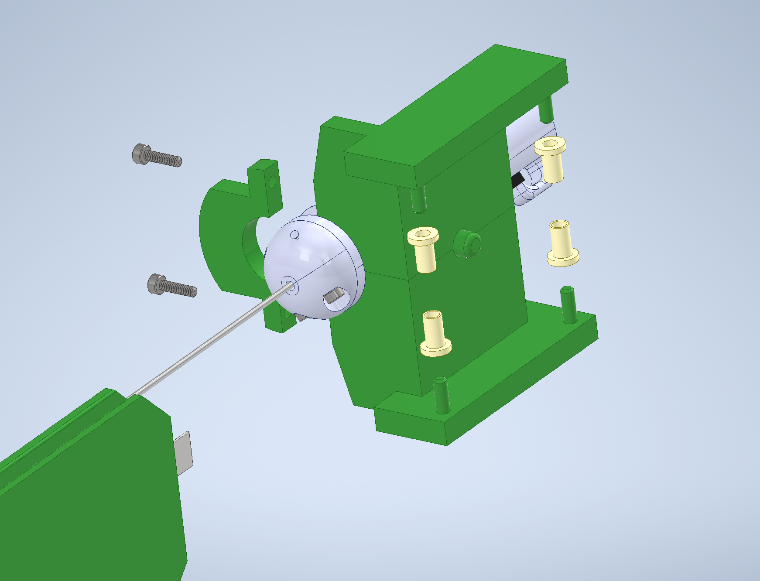

Carriage Clamp

Carriage

(4) Sleeve Washer

Needle Assembly

(2) M2-0.4x8 SHC

* Place Needle Assembly against Carriage, lining up groove in Needle Assembly with Carriage wall
* Place Carriage Clamp over Needle Assembly groove, against Carriage, secure with (2) M2-0.4x8 SHC Screws
* Insert (4) Sleeve Washers onto prongs of Carriage, leave small gap between Washers and Carriage
* Slide Sleeve Washers into Rail, inserting Needle into Needle Guide, and ensure that Washer surfaces are flush and slightly in contact with rail, and can slide smoothly along Rail (may need to sand Rail inner surfaces smoother)
* Apply glue to Sleeve Washers to secure it to Carriage when motion is smooth